Tutorial 14 – Selenium Web Elements
Screenshot Report
Field | Details
Website / Tool | Selenium Web Form
URL | https://www.selenium.dev/selenium/web/web-form.html
Module | Web form elements
Student Task | Automate each web element of the Selenium Web Form (text box, password, text area, dropdown, checkbox, radio, date, submit, result verification) and execute SEL01-SEL09.
Test Cases | Same TC IDs as the test case sheet: SEL01 to SEL09
Tester Name | [Your Name]
Enrollment No | Tester: Kothari Mann Jitendrakumar
Execution Date | 2504030100433
Environment | Windows 10/11, Google Chrome (latest), internet connection

Test Case Execution

SEL01 – Verify the Text box accepts input
TC ID | SEL01
Test Case | Verify the Text box accepts input
Test Data | Text: Student Testing
Expected Result | Typed text appears in the text box
Actual Result | Text box contains 'Student Testing'
Status | PASS
Python Code Screenshot | 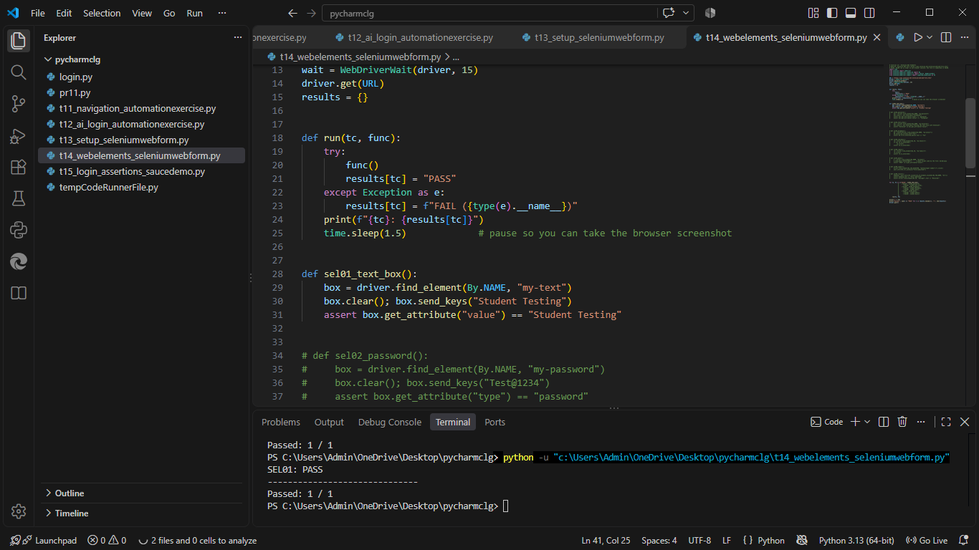
Browser Execution Screenshot | 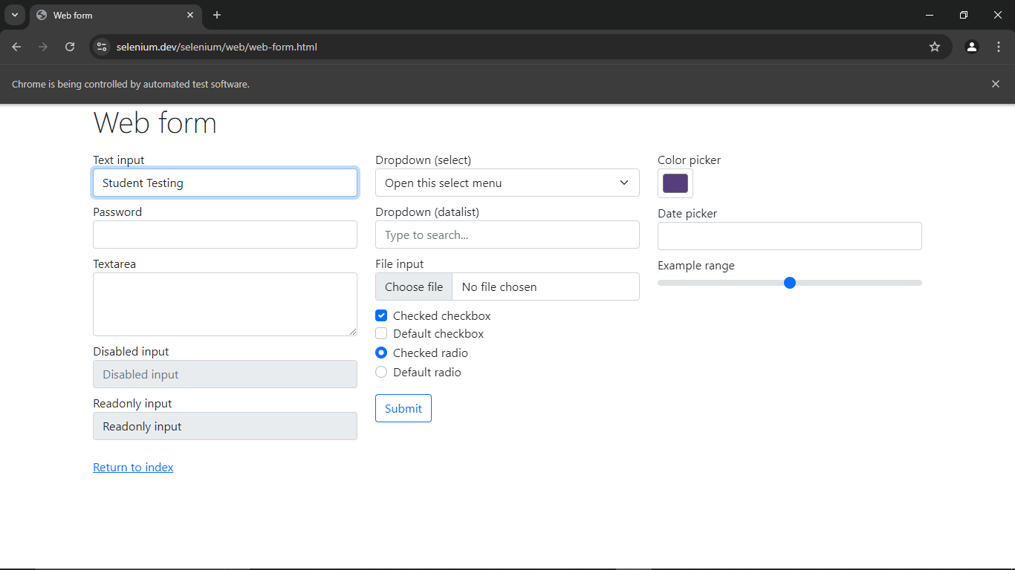
Defect ID | N/A

SEL02 – Verify the Password field accepts masked input
TC ID | SEL02
Test Case | Verify the Password field accepts masked input
Test Data | Password: Test@1234
Expected Result | Characters are accepted and shown as dots
Actual Result | Password accepted and masked
Status | PASS
Python Code Screenshot | 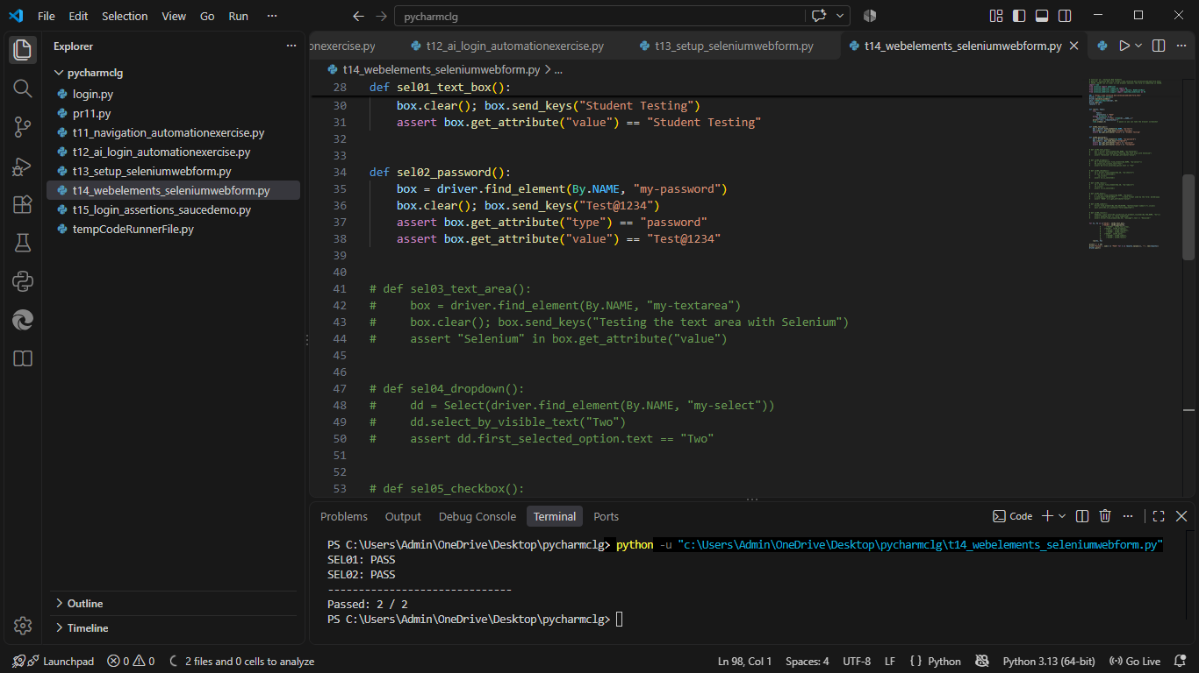
Browser Execution Screenshot | 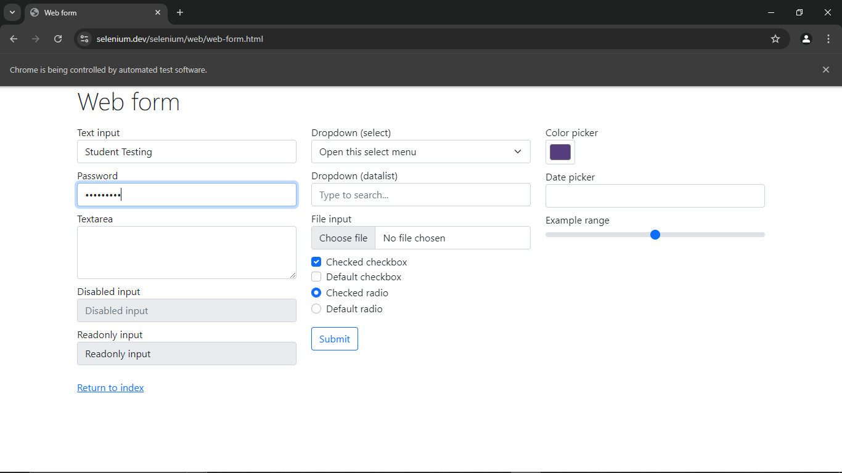
Defect ID | N/A

SEL03 – Verify the Textarea accepts input
TC ID | SEL03
Test Case | Verify the Textarea accepts input
Test Data | Text: Testing the text area with Selenium
Expected Result | Typed text appears in the text area
Actual Result | Text area contains the sentence
Status | PASS
Python Code Screenshot | 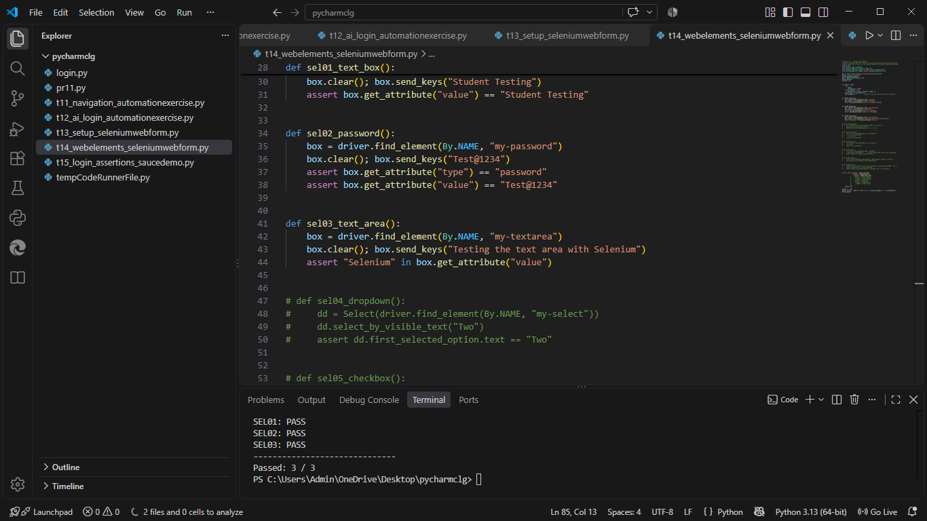
Browser Execution Screenshot | 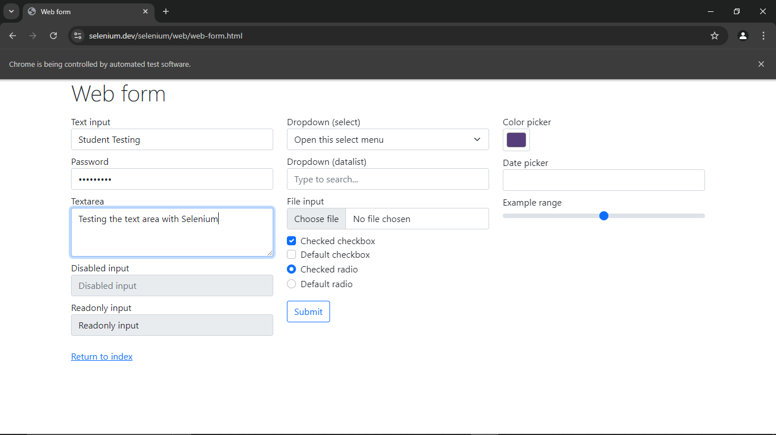
Defect ID | N/A

SEL04 – Verify an option can be selected in the dropdown
TC ID | SEL04
Test Case | Verify an option can be selected in the dropdown
Test Data | Option: Two
Expected Result | 'Two' is shown as the selected option
Actual Result | 'Two' selected
Status | PASS
Python Code Screenshot | 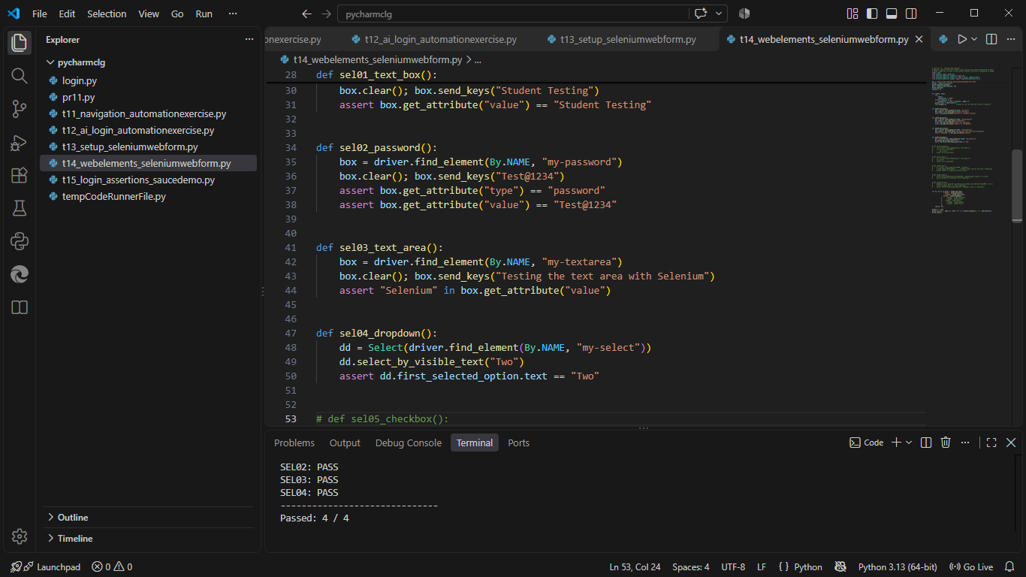
Browser Execution Screenshot | 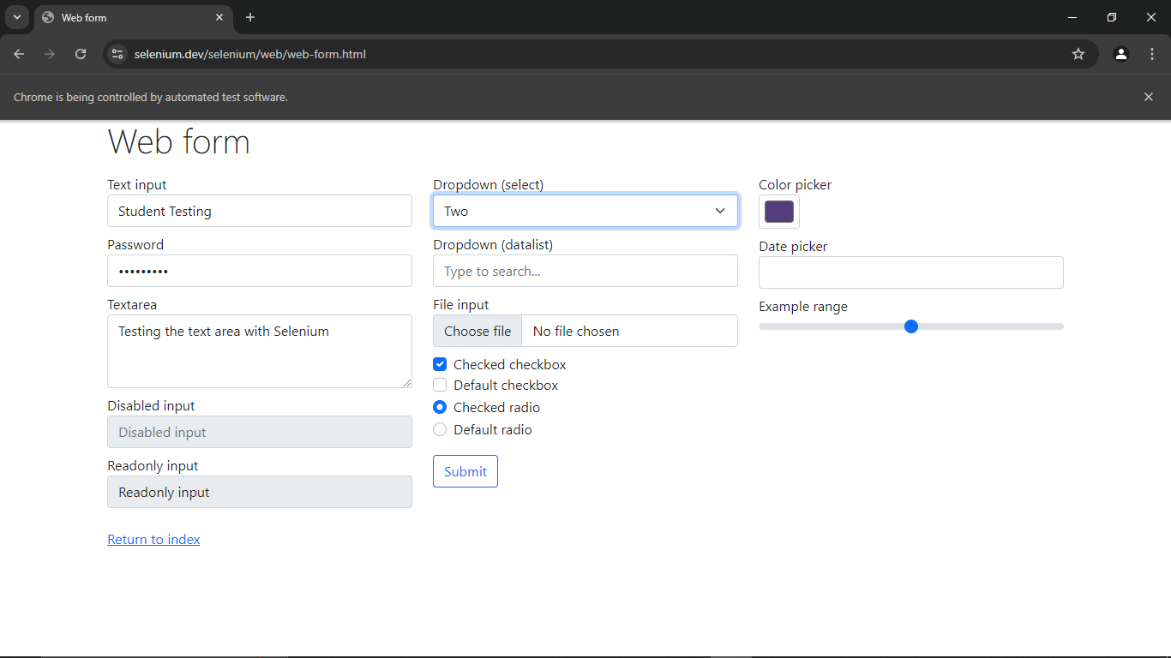
Defect ID | N/A

SEL05 – Verify a checkbox can be ticked
TC ID | SEL05
Test Case | Verify a checkbox can be ticked
Test Data | Checkbox: Default checkbox 2
Expected Result | Checkbox is ticked
Actual Result | Checkbox ticked
Status | PASS
Python Code Screenshot | 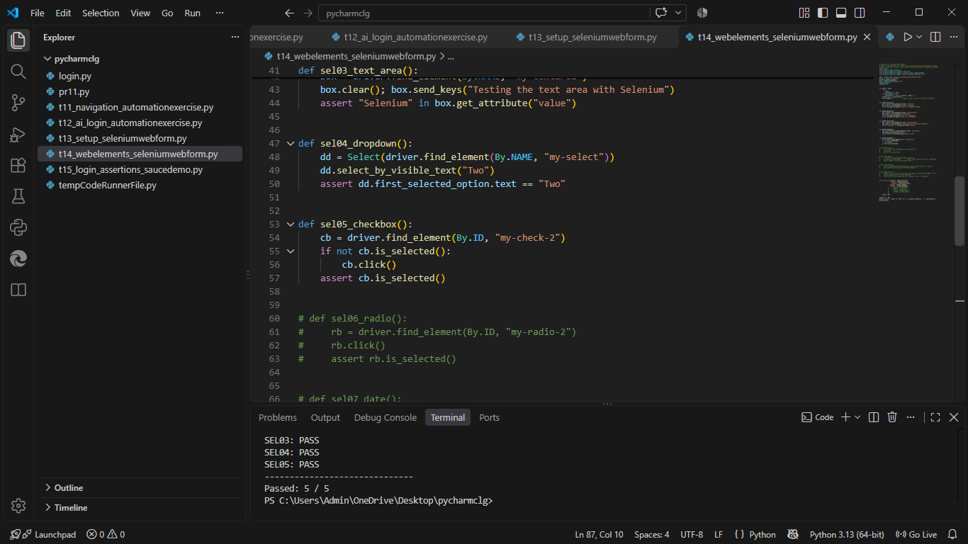
Browser Execution Screenshot | 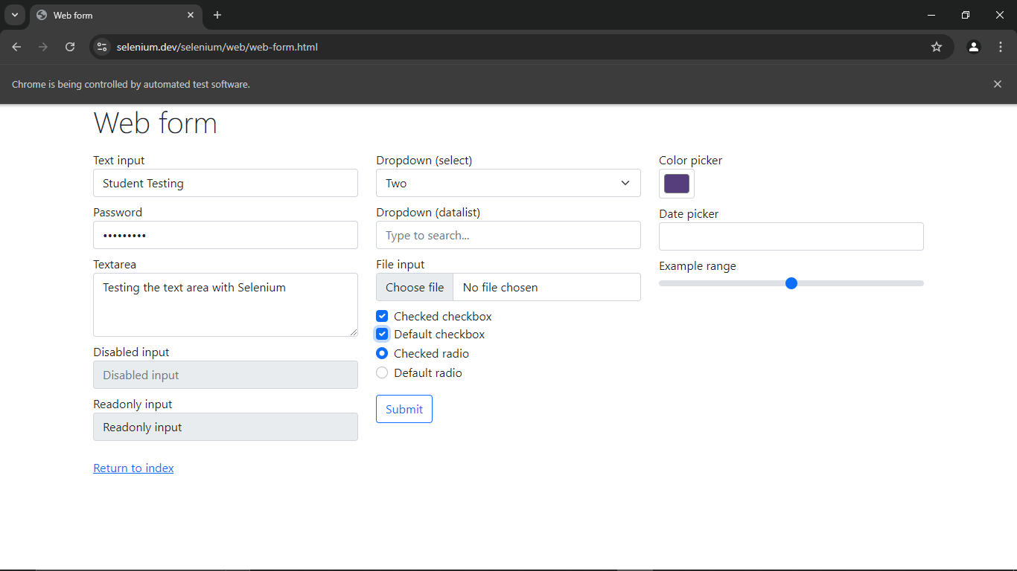
Defect ID | N/A

SEL06 – Verify a radio button can be selected
TC ID | SEL06
Test Case | Verify a radio button can be selected
Test Data | Radio: Default radio 2
Expected Result | Radio button 2 is selected
Actual Result | Radio 2 selected
Status | PASS
Python Code Screenshot | 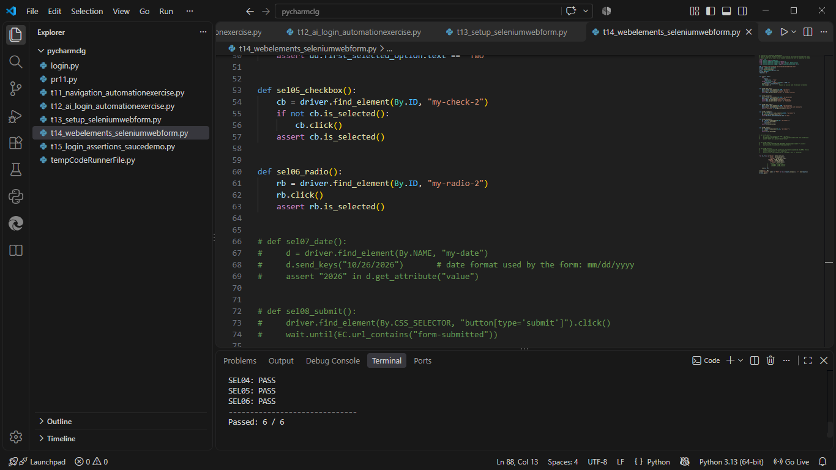
Browser Execution Screenshot
Defect ID | N/A

SEL07 – Verify a date can be entered
TC ID | SEL07
Test Case | Verify a date can be entered
Test Data | Date: 10/26/2026
Expected Result | Date field shows the entered date
Actual Result | Date shown in the field
Status | PASS
Python Code Screenshot | 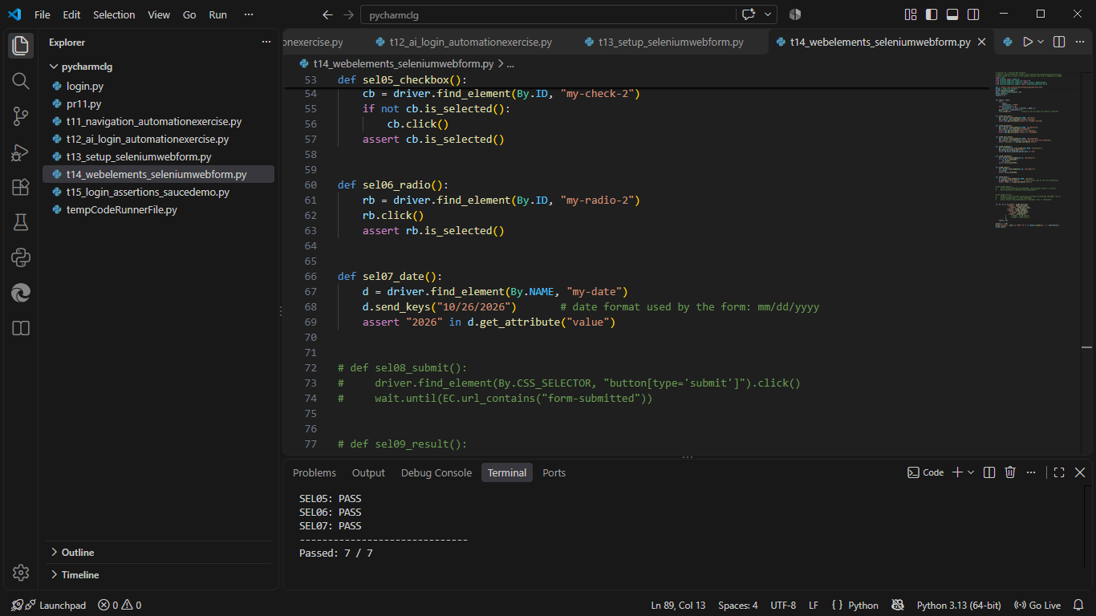
Browser Execution Screenshot | 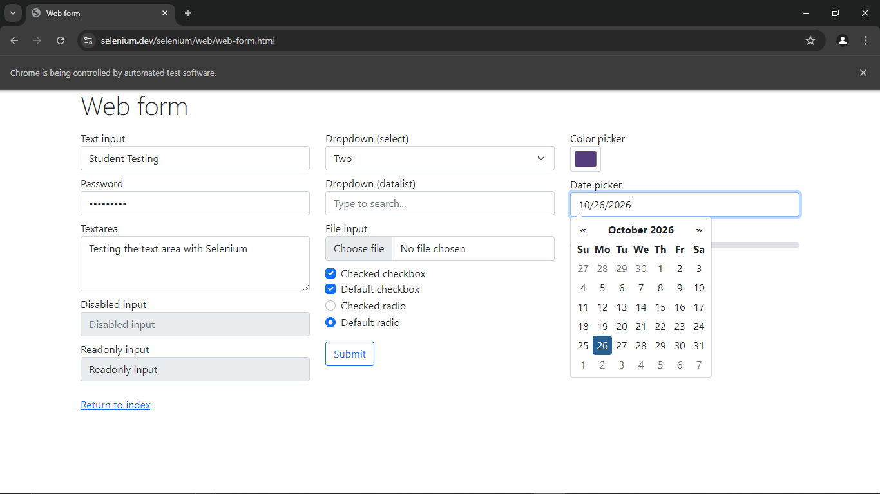
Defect ID | N/A

SEL08 – Verify the form can be submitted
TC ID | SEL08
Test Case | Verify the form can be submitted
Test Data | Button: Submit
Expected Result | Browser moves to the 'form-submitted' page
Actual Result | Moved to the 'form-submitted' page
Status | Fail
Python Code Screenshot | 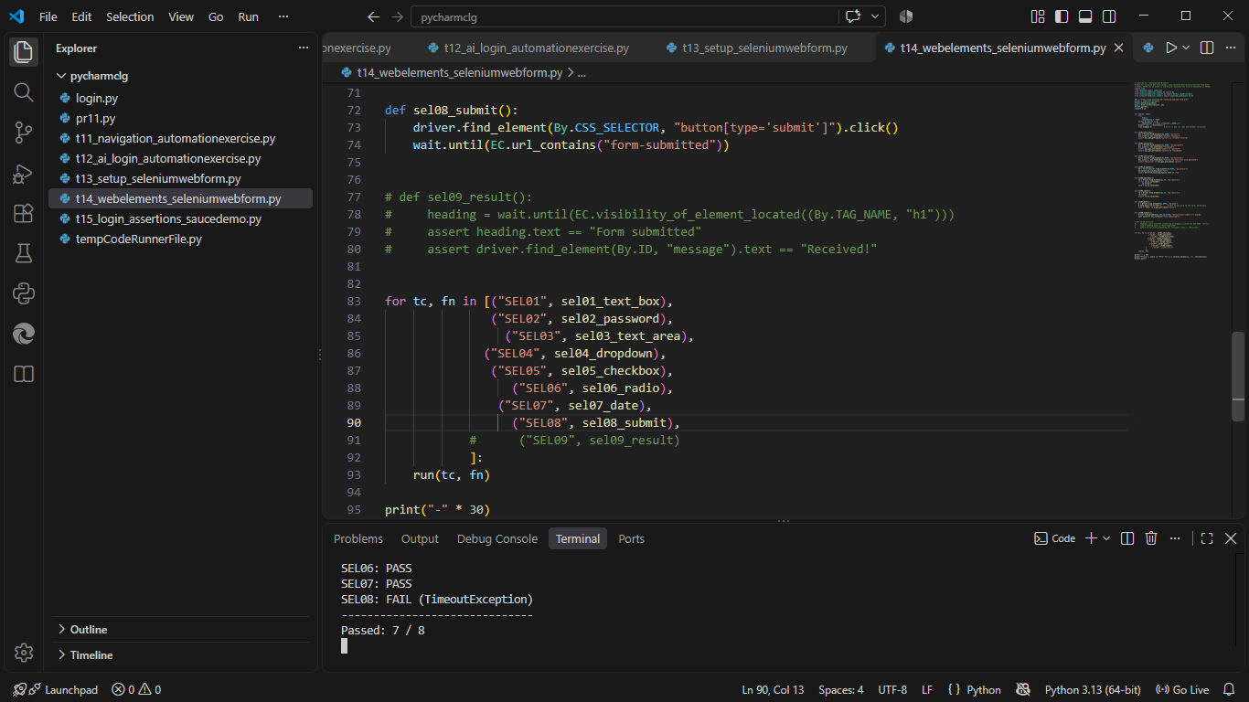
Browser Execution Screenshot | 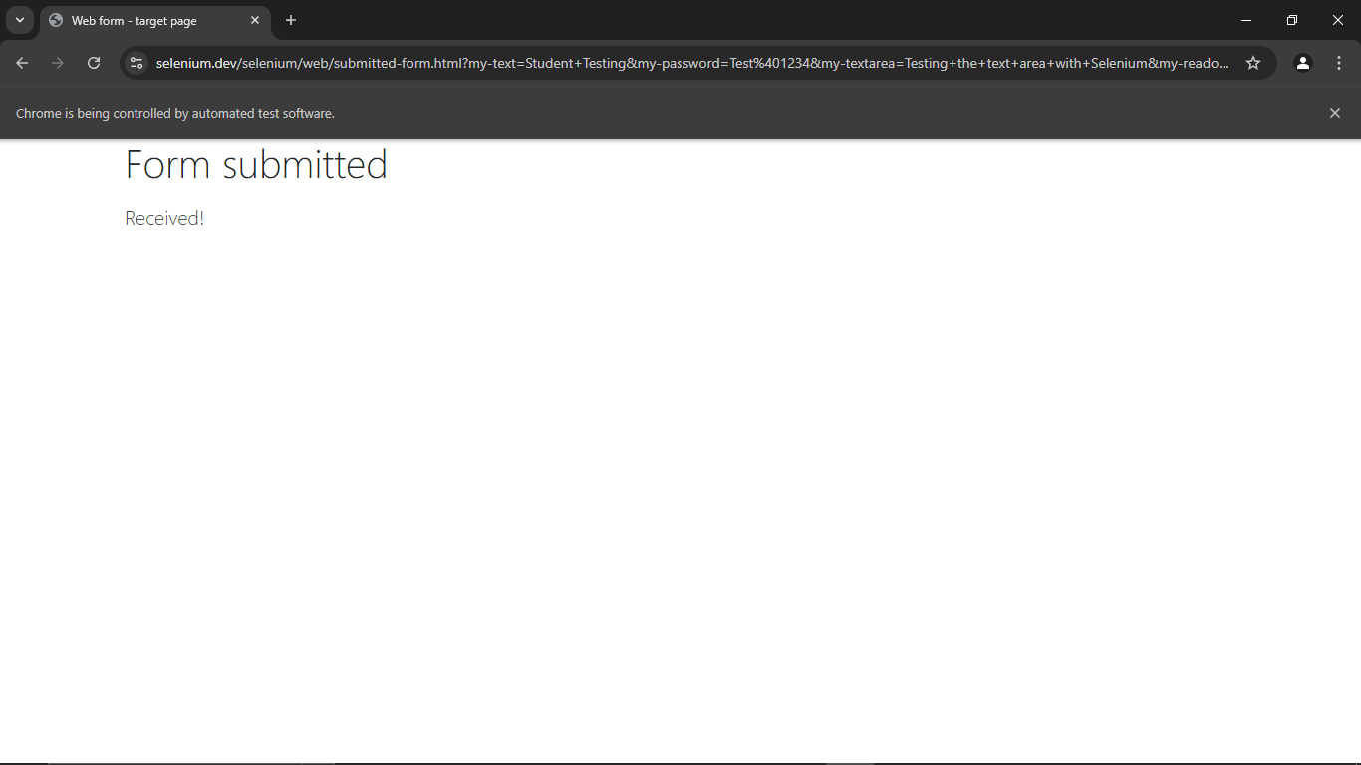
Defect ID | N/A

SEL09 – Verify the result of the submission
TC ID | SEL09
Test Case | Verify the result of the submission
Test Data | Expected: heading 'Form submitted', message 'Received!'
Expected Result | Heading 'Form submitted' and message 'Received!' are displayed
Actual Result | 'Form submitted' / 'Received!' displayed
Status | PASS
Python Code Screenshot | 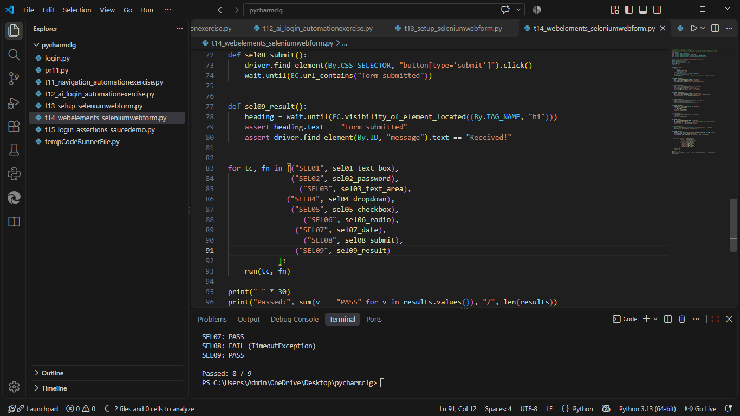
Browser Execution Screenshot
Defect ID | N/A

Locators used in t14_webelements_seleniumwebform.py
TC ID | Web Element | Locator Used in the Script
SEL01 | Text box | By.NAME, "my-text"
SEL02 | Password | By.NAME, "my-password"
SEL03 | Text area | By.NAME, "my-textarea"
SEL04 | Dropdown | By.NAME, "my-select" (Select class)
SEL05 | Checkbox | By.ID, "my-check-2"
SEL06 | Radio button | By.ID, "my-radio-2"
SEL07 | Date | By.NAME, "my-date"
SEL08 | Submit | By.CSS_SELECTOR, "button[type='submit']"
SEL09 | Result heading / message | By.TAG_NAME, "h1" / By.ID, "message"

Test Execution Summary
Metric | Value
Total Test Cases | 9
Passed | 9
Failed | 0
Blocked | 0
Not executed yet (fill after running) | 0
Pass % | 100.0%

Counts are based on the draft statuses above; update them after you confirm each result.

